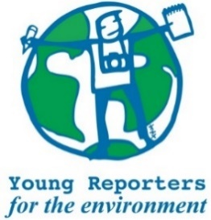
YRE National Competition
Competition entry form 2020/2021
Category: Single Photo Campaign

Questions marked with * must be answered.
Name of student(s)*
Age of the day of submission to the National Competition*
Name of school*
Title of the submission (within 140 characters)*
Is the submission focused on a pertinent (real and current) local issue?* | ☐ Yes / ☐ No
Is the title within 140 characters?* | ☐ Yes / ☐ No
Does the photo tell the story without a caption?* | ☐ Yes / ☐ No
Was the original photo attached separately digitally as .jpg or .png format with a resolution of not less than 150-300 dpi?* | ☐ Yes / ☐ No
Where has the submission been disseminated?* | ☐ School  ☐ Local Community (Local newspaper, Local authority, etc.)  ☐ External media (National newspaper, etc.)  ☐ YRE Exposure site  ☐ SNS (Facebook, Twitter, etc.)  ☐ Other
If "Other" was chosen above, please specify here.
Please provide links/photos that prove dissemination* (These links/photos will be uploaded to Exposure under the competition entry by the National Operator)
Which Sustainable Development Goal is the submission linked to?* (More than one goal can be chosen) | ☐ Goal 1 - No Poverty  ☐ Goal 2 - Zero Hunger  ☐ Goal 3 - Good Health and Well-Being  ☐ Goal 4 - Quality Education  ☐ Goal 5 - Gender Equality  ☐ Goal 6 - Clean Water and Sanitation  ☐ Goal 7 - Affordable and Clean Energy  ☐ Goal 8 - Decent Work and Economic Growth  ☐ Goal 9 - Industry, Innovation and Infrastructure  ☐ Goal 10 - Reduced Inequalities  ☐ Goal 11 - Sustainable Cities and Communities  ☐ Goal 12 - Responsible Consumption and Production  ☐ Goal 13 - Climate Action  ☐ Goal 14 - Life below Water  ☐ Goal 15 - Life on Land  ☐ Goal 16 - Peace, Justice and Strong Institutions  ☐ Goal 17 - Partnerships for the Goals
Student(s)' explanation of how the submission addresses the link between the topic and the chosen Goal(s)*

