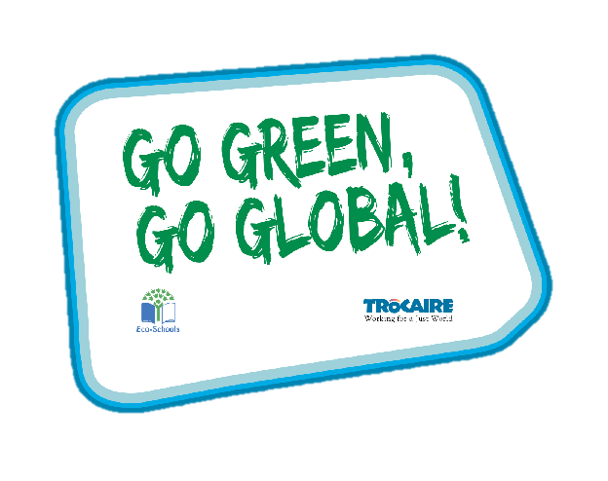
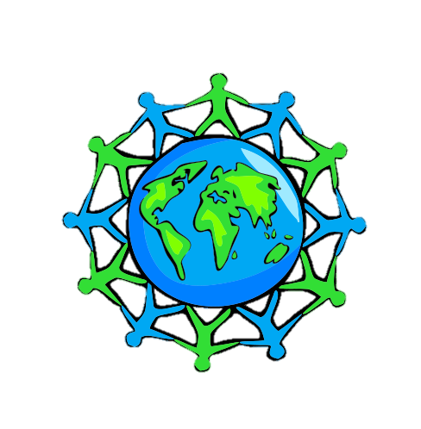
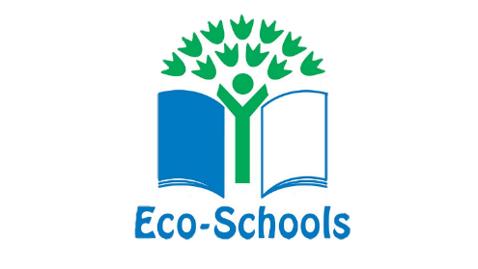
Global Perspective
Water
Climate Action
Foundation Stage





‘Whole Class Activity’ Resource Booklet

The purpose of this resource
The Eco-Schools programme in Northern Ireland is operated by Keep Northern Ireland Beautiful and addresses the following eleven topics within schools:
Biodiversity Energy Global Perspective Healthy Living
Litter Marine Transport Waste
Water Climate Action School Grounds (outdoor learning)
In order to qualify for the much acclaimed 'Green Flag' award level, schools must have shown substantial progress towards completing 'one large scale project topic and indicated involvement with two others'.
Through the expertise of the Irish development agency Trócaire, this resource provides a range of activities to incorporate a global perspective into the classroom. It will focus on three of the eleven Eco-School topics and will explain how to introduce and explore these global issues with your pupils.
Each section contains an information sheet on the global issue and one whole class activity.

Content
Section 1 – Global Perspective 3-7
Section 2 – Water 8-10
Section 3 – Climate Change 11-12

Section 1: Global Perspective
Exercise 1: Discussion around our different appearances

Aim: Recognising we are all different, we are all unique

Step 1: Look at the photos of all the children in the PowerPoint – if possible, please print individually and place in pairs around different desks in the room.

Step 2: In pairs or groups of three have pupils walk around the room, discussing the similarities and differences of each individual in the photo.

Step 3: Open a discussion on what is different and what is the same about each-other.

Step 4: Thumbs up, Thumbs down (or alternatively move from one side of the class to the other) – go through the likes and dislikes on the PowerPoint.

Step 5: Explain Nobody in the WORLD looks the same, thinks the same, feels the same, believes the same or behaves, exactly the same way as...YOU!
You are Special and You Are Unique!

Exercise 2: Traditional Clothing form around the world

Aim: To give a broader understanding of different cultures and traditions

Materials: Worksheet, pencil and colours

Step 1: Go through the 6 different traditional clothing items and discuss each one of them with the class.

Step 2: See if pupils are able to match the black and white pictures with the correct country by joining them with a line.

Step 3: Pupils then colour in their worksheet.

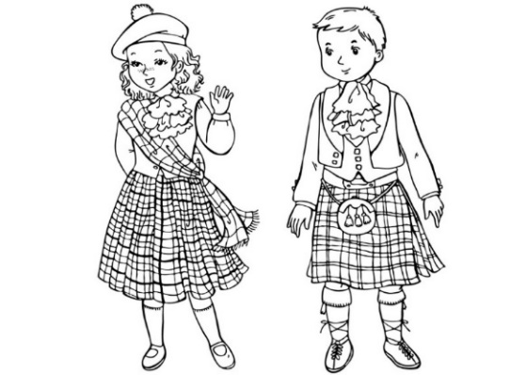
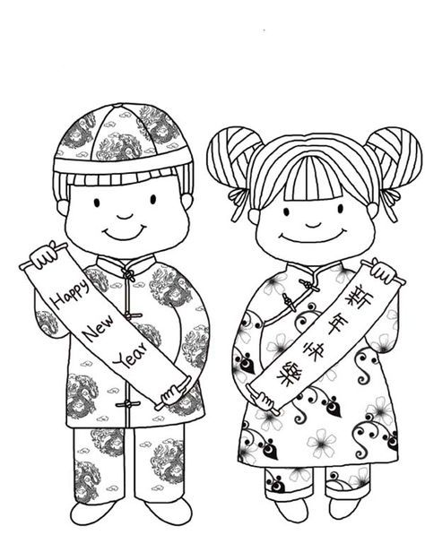
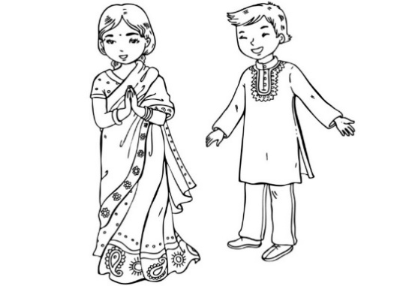
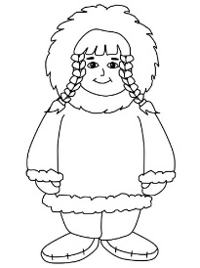
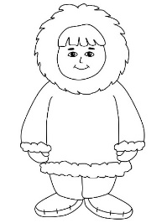
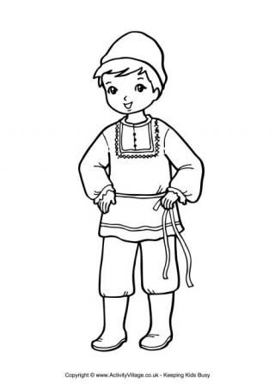
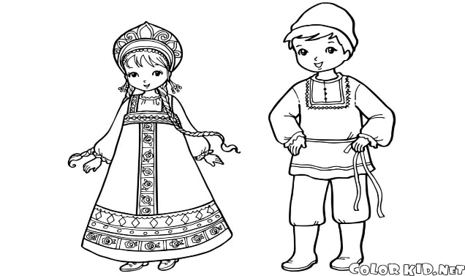
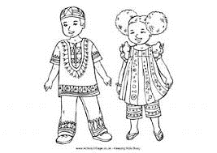
INDIA
RUSSIA
SCOTLAND
CHINA
ALASKA
EAST AFRICA

Exercise 3: Wants and Needs of living things.

Aim: to understand the difference between a want and a need

Materials: Internet connection to play the video

Step 1: Watch the internet video as a class.

Step 2: Thumbs up, thumbs down or one side of the room is a want and the other is a need.

Step 3: Discuss each want or need individually to ensure understanding.

Step 4: Explain many children/people get to have all these things (both their needs and wants) however some children even here in this classroom may not get all these things.

Step 5: Open a discussion around: Is it fair that not everyone has access to basic needs/essentials for living? Why do you think this is? How does it make you feel?

Step 6: Discuss with the class, what is family and the bonds that hold it together?

Exercise 4: Different foods from around the world
Aim: to understand the variety of food that we consume from across the world and to be very grateful for it

Materials: PowerPoint

Step 1: Ask the children, have they ever eaten foods from other country’s, or do they know of any?

Step 2: Talk through each of the foods and see how many have tried new things. Remember the importance of encouraging them to try new foods.

Background:

Italy is famous for its pasta dishes, sauces and wines. Italians use a variety of fresh ingredients to make their meals. Lasagna and Spaghetti Bolognese are often made with tomatoes, meat, pasta, olive oil and herbs.

Irish Stew is a dish native to Ireland that is traditionally made with root vegetables and lamb or mutton, but also commonly with beef.

An English breakfast is a big hearty meal! Beans, bacon, eggs, sausages, tomatoes, toast, and a cup of tea are just some of its tasty ingredients.

Food in Malawi is extremely diverse with tea and fish being very popular features of the country’s cuisine. Most Malawians, enjoy Nsima, which is a food staple made from ground corn and typically served with side dishes of meat and vegetables. It is commonly eaten for lunch and dinner.

India is famous for its yummy, spicy food. Indian cooking uses lots of spices to make the food smell, taste and look delicious. Thalis are a selection of several, small portions of different things, e.g. chutney, rice, yogurt, curry… they are also one of the most popular foods in the UK.

Paella is a famous Spanish dish. It is made using seafood and vegetables and lots of rice! Omelettes are made using lots of eggs, potatoes, herbs, meat and vegetables.

Jerk Chicken refers to the way it has been cooked. After the meat has been thoroughly cleaned it is smoked in a deep pit or on a BBQ. It is then smothered in a spicy sauce. Curried Goat is also a favourite Caribbean dish. Have you ever eaten it at home?

Turkish and Greek people eat lots of different types of olives especially at breakfast time. Mezze and Kebabs are famous dishes from both countries. Mezze are lots of little plates of food like, humus, olives, stuffed peppers, feta cheese, fried aubergine, vine stuffed leaves. Spicy rice. Turkey and Greece are both famous for making Kebabs as well as pastry dishes. Turkey is also known for making Baklava, a sweet filo pastry dessert.

Exercise 5: Is our food shared fairly around the world?

Aim: To help children understand that we must share and treat each-other fairly, especially with those things we need to survive.

Materials: sweets or fruit

Step 1: Give one pupil a paper plate with only enough to serve half the class a sweet. Make it clear that they are not allowed to eat the sweet until told to. They must give them out in the order of the desks in front of them (not to their friends first).

Step 2: Gauge reactions when the pupil and their peers begin to realise that not everyone is going to receive something.

Step 3: Once it is clear, that there are not enough sweets and fruits for everyone, ask those who did not get a sweet, how did it make them feel? A similar line of inquiry could be followed with the pupil dispensing items.

Step 4: Explain that, unfortunately, the things we need in life are not always shared out fairly. Across the world there are many children who have no food and are starving so it is important to share and be kind to everyone throughout their life.

Section 2: Water

Background information
Water features heavily in our everyday lives. It is very important for all living things. There is a current threat of running out of freshwater around the world. Therefore, we need to take action and save water as best we can. On the other hand, it is important to remember that extreme weather can cause negative affects from flooding.
Exercise: Items around the house which use water
Aim: To identify the items which use water and think of solutions to help reduce the use of water.
Material needed: Worksheet of items and ‘Items around the house which use water’ worksheet.
Step 1: Discuss the importance of water with the class. How have they used water this morning?
Step 2: Complete the ‘Items around the house which use water’ by cutting and sticking the items into the appropriate places.
Step 3: Once you have completed your list of items which use water, discuss which item you think uses the most water at one time and which uses the least.
Step 4: Discuss steps that can be taken to reduce the use of water within a household. For example, always put on a FULL wash (for washing machine and dish washer), collect rainwater to water your plants in the garden and take a shower instead of a bath.
Step 5: Go home and tell your family about all the wonderful water we can save. Encourage them to do the same.

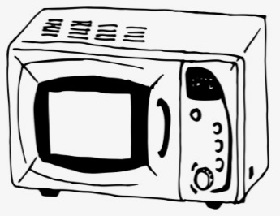
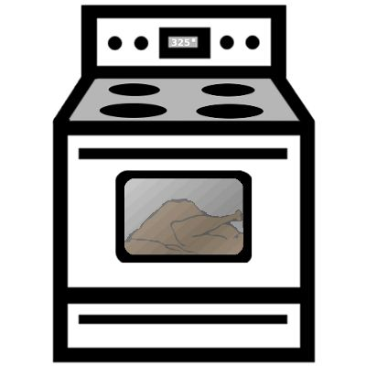
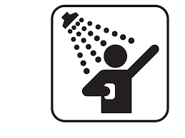

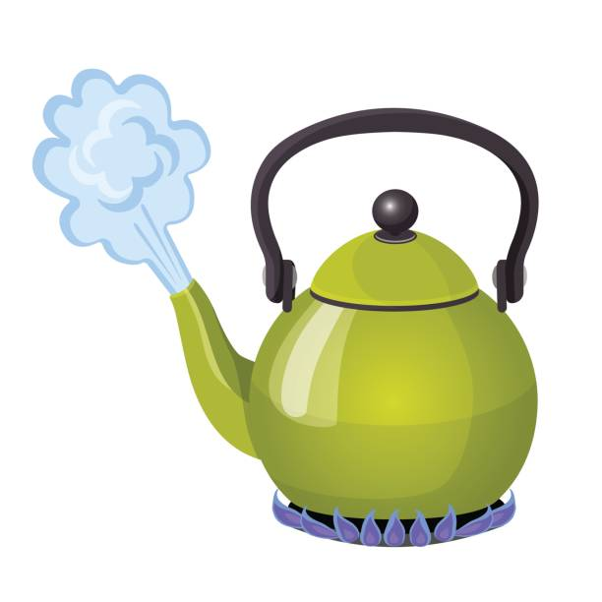




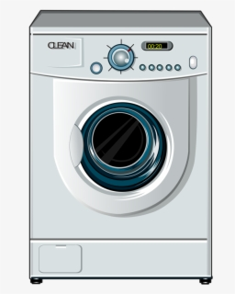
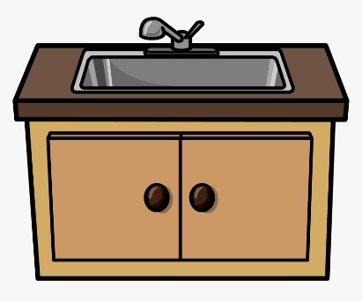
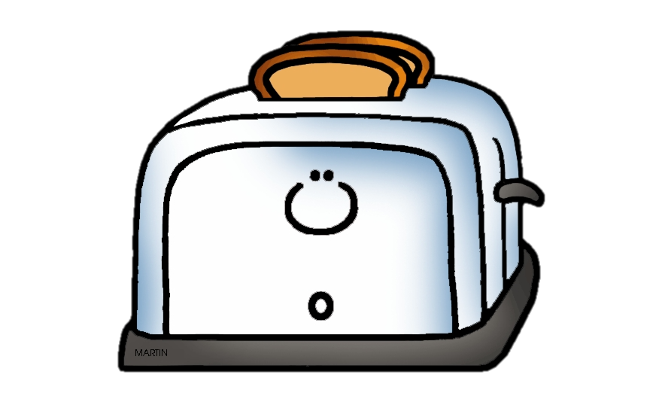

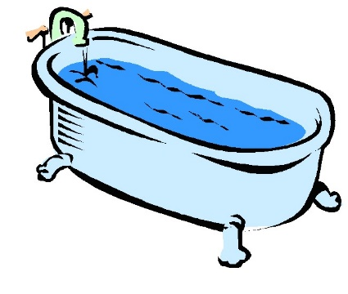
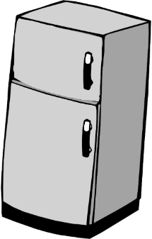

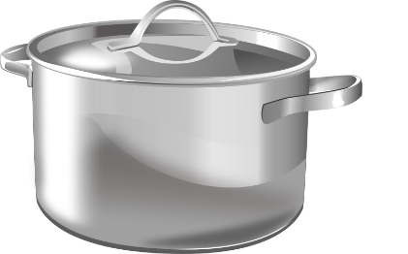

Items around the house which use water.
Uses water | Does not use water

Section 3: Climate Change
Background information
Planet Earth’s temperature is rising rapidly, as a consequence of, human activities. If we don’t stop exploiting the planets natural resources by the overuse of cars and commercial goods, it’s temperature will continue to rise. A rising temperature leads to a higher number of natural disasters across the planet.
Exercise: The Earth is becoming sick
Aim: To identity human activities which are good for Planet Earth and those which are bad for Planet Earth
Material needed: ‘Help the Earth get better’ worksheet.
Step 1: Start by discussing with your class the likelihood of being sick from eating too many sweets, crisps or biscuits (bad food). Talk about how your temperature begins to rise and subsequently makes you feel unwell.
Step 2: Explain that this is very similar to how planet Earth reacts when it ‘eats’ too much from human activities. When we have too many cars on the road or use too much water, the planets temperature begins to rise, and it starts to feel very ill. This is known as Climate Change
Step 3: Explain that we are able to help the planet feel better, if we all work together. We need to adopt a healthier, simpler lifestyle for the planet to recover from its sickness. When we are sick, we eat less, rest more and try to do things that are good for our body to recover quickly. We need to do the same for planet Earth.
Step 4: Complete the worksheet, identifying human activities which are good and bad for the planet. Circle things which are good for planet Earth (GREEN) and those which are bad for planet Earth (RED).
Step 5: Now try to live out these good behaviours which help our planet.

Help Planet Earth get better.
Circle things that are good for Earth (GREEN)
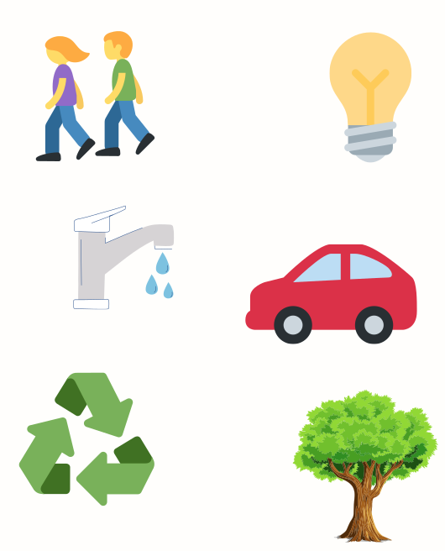
Circle things that are bad for Earth (RED)
Walking
Leaving lights on
Driving a car
Planting a tree
Wasting water
Reduce, Reuse, Recycle

