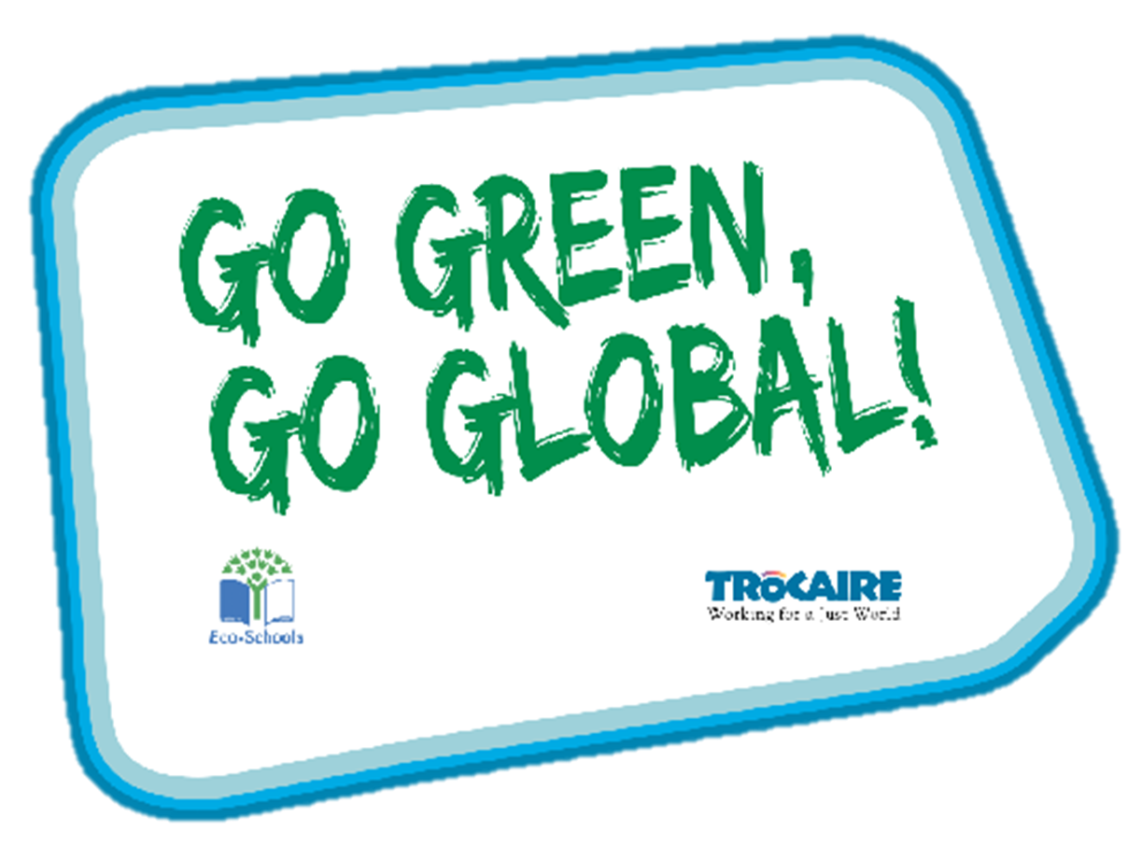

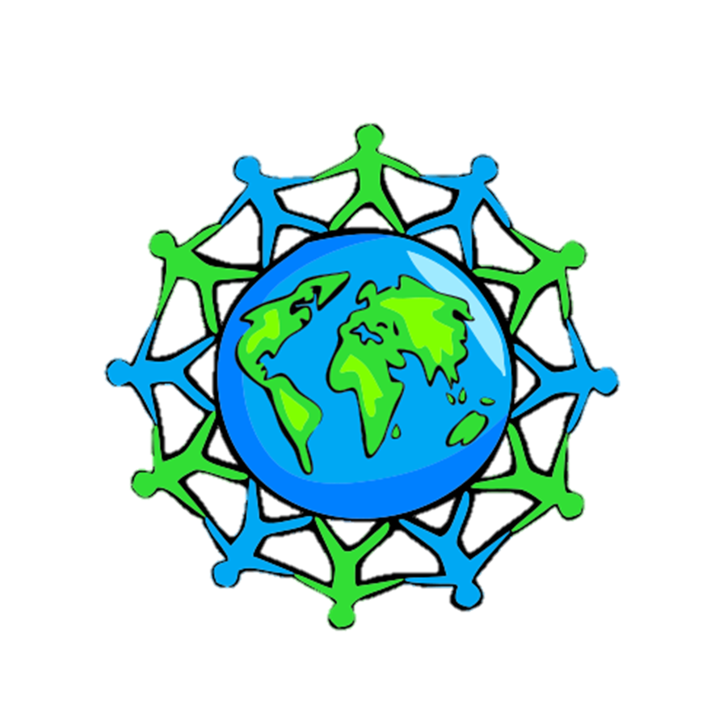

Global Perspective
Water
Climate Change


Key Stage 1

Whole Class Activity’ Resource Booklet
The purpose of this resource
The Eco-Schools programme in Northern Ireland is operated by Keep Northern Ireland Beautiful and addresses the following eleven topics within schools:
Biodiversity Energy Global Perspective Healthy Living
Litter Marine Transport Waste
Water Climate Change School Grounds (outdoor learning)
In order to qualify for the much acclaimed 'Green Flag' award level, schools must have shown substantial progress towards completing 'one large scale project topic and indicated involvement with two others'.
Through the expertise of the Irish development agency Trocaire, this resource provides a range of activities to incorporate a global perspective into the classroom. It will focus on three of the eleven Eco-School topics and will explain how to introduce and explore these global issues with your pupils.
Each section contains an information sheet on the global issue and one whole class activity.
Content
Section 1 – Global Perspective 3 - 11
Section 2 – Water 12 - 13
Section 3 – Climate Change 14 - 15

Section 1: Global Perspective
Background information: Global citizenship
Being a global citizen is not clearly defined. As there is no global government there are no clear rules and regulations and globally, we do not have democratically elected representatives to speak for us.
Global citizenship is more a moral understanding of our responsibilities and our rights in a global context. Being a true global citizen means that we recognise that all people have equal rights and value diversity.
In addition, it means we should value planet earth as our common home and one which we all have a need and indeed a responsibility, to look after.
Exercise 1: Discussion around our different appearances
Aim: Recognising we are all different, we are all unique
Step 1: Look at the photos of all the children in the PowerPoint – or alternatively print individually and place in pairs around different desks in the room.
Step 2: In pairs or groups of three have pupils them walk complete a walking activity whereby they visit different tables identifying differences and similarities between photos.
Step 3: Open discussion on what is different and what is the same about each person in the photo.
Step 4: Thumbs up, Thumbs down (or alternatively move from one side of the class to the other) – go through the likes and dislikes on the PowerPoint.
Step 5: Explain Nobody in the WORLD looks the same, thinks the same, feels the same, believes the same or behaves exactly the same way as...YOU!
You are special and You are Unique!
Exercise 2: Traditional Clothing form around the world
Aim: To give a broader understanding of different cultures and traditions
Materials: Worksheet, pencil and colours
Step 1: Go through the 6 different traditional clothing items and discuss each of them.
Step 2: See if the pupils are able to match the black and white pictures with the correct country by joining them with a line.
Step 3: Pupils then colour in their worksheet.
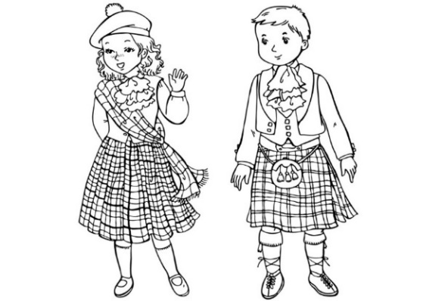
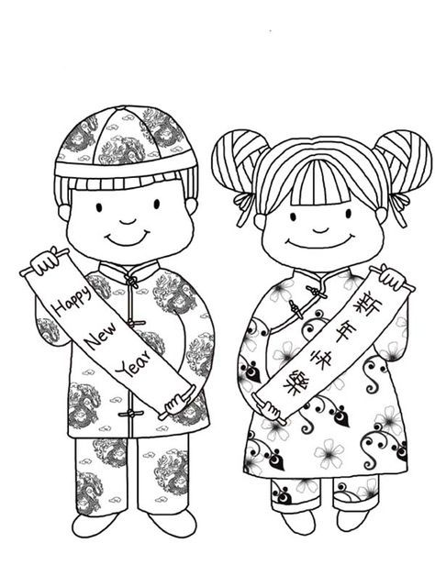
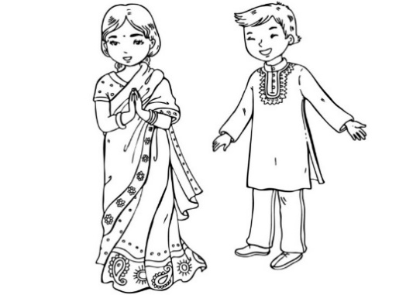
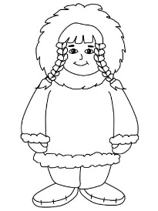
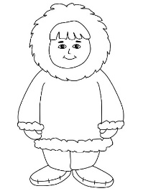
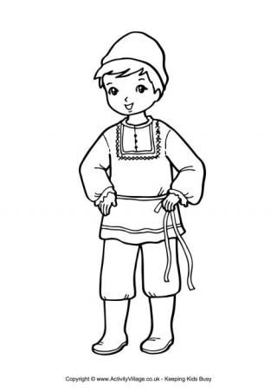
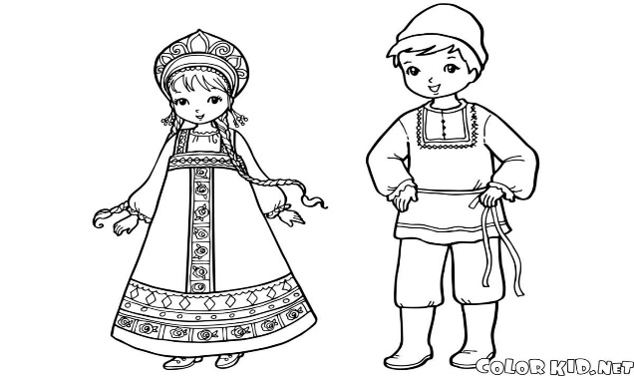
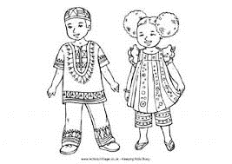
INDIA
RUSSIA
SCOTLAND
CHINA
ALASKA
EAST AFRICA
Background: Global Environment
The term environment means surroundings, natural world. However, it can be narrowly defined, for example our immediate surroundings as in the classroom environment or very broadly, in relation to the global environment.
One thing that is certain is that humankind has had a huge impact on the environment. Today, many of us have acquired so many things that we have a very comfortable life. But at what cost?
The more that people take from the environment, the more they change the pattern of nature. If we take too much, we risk upsetting this balance.
The balance of nature changes slowly over time but in recent years we have wanted more and more for ourselves and we are upsetting the balance at a faster rate, without even realising it.
We are part of the natural environment and must look after it. If we upset the pattern too much, we may even destroy ourselves and the lives of future generations.
Trócaire’s focus is on ensuring that our global resources are shared equitably and those in power act for the common good of all.

Exercise 3: Wants and Needs of living things
Aim: To understand the difference between a want and a need
Materials: Internet connection to play the video
Step 1: Watch the internet video as a class. (link on PowerPoint)
Step 2: Thumbs up thumbs down or one side of the room is a want, and the other is a need.
Step 3: Discuss each want or need individually to ensure understanding.
Step 4: Explain many children/people get to have all these things (both their needs and wants) however some children even here in this classroom may not get all these things.
Step 5: Open a discussion around: Is it fair one person should get something while other person goes without?
Step 6: Family and love should be discussed – these are things we need to look after our emotional health.
Step 7: Cut out the different wants and needs and stick them into the correct half of the table e.g. Water is a need.
Needs and Wants
Needs  we have a right to these things | Wants  we might like these things, but do we need them?

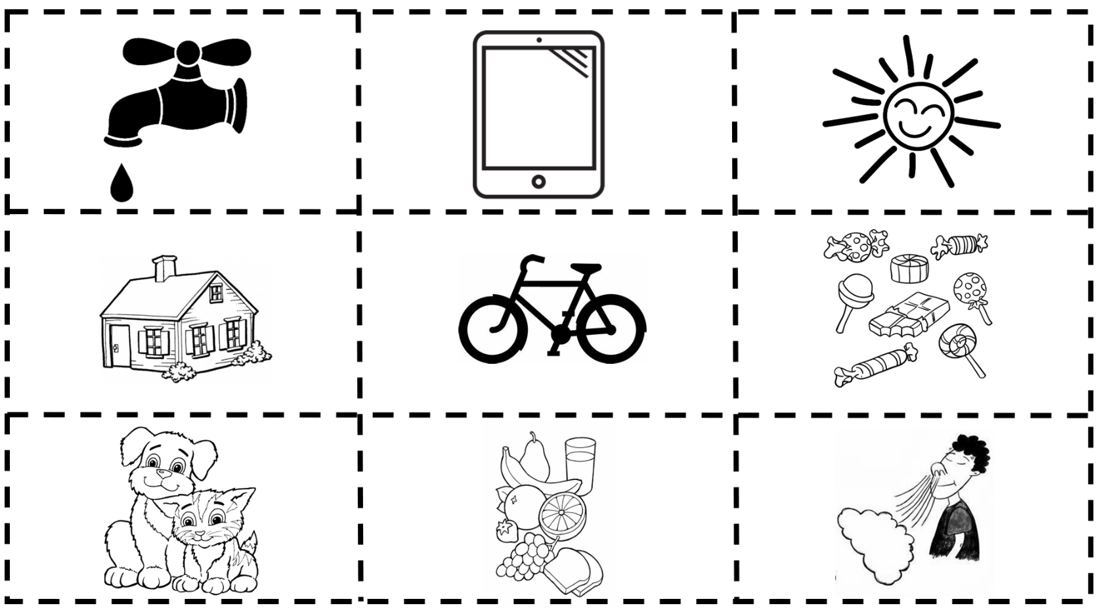

Exercise 4: Different foods from around the world
Aim: to understand the variety of food that we consume from across the world and to be very grateful for it
Materials: PowerPoint
Step 1: Ask the children have the ever-eaten foods from other countries or do they know of any?
Step 2: Talk through each of the foods and ask students if they have tried any of these. Remember the importance of encouraging them to try new foods and things.
Background:
Italy is famous for its pasta dishes, sauces and wines. Italians use a few fresh ingredients to make their meals. Such as Lasagna and Spaghetti Bolognese made often with Tomatoes, meat, pasta, olive oil, herbs…
Irish Stew is a dish native to Ireland that is traditionally made with root vegetables and lamb or mutton, but also commonly with beef.

An English breakfast is a big hearty meal! Beans, bacon, eggs, sausages, tomatoes, toast, and a cup of tea are just some of its tasty ingredients.

Food in Malawi is extremely diverse with tea and fish being very popular features of the country’s cuisine. Most Malawians, enjoy Nsima, which is a food staple made from ground corn and typically served with side dishes of meat and vegetables. It is commonly eaten for lunch and dinner.

India is famous for its yummy spicy food. Indian cooking uses lots of spices to make the food smell, taste and look delicious. Thalis are a selection of several small portions of different things, e.g. chutney, rice, yogurt, curry… they are one of the most popular foods in the UK.
Paella is a famous Spanish dish. It is made using seafood and vegetables and lots of rice! Omelettes are made using lots of eggs, potatoes, herbs, meat and vegetables.

Jerk Chicken refers to the way it has been cooked. After the meat has been thoroughly cleaned it is smoked in a deep pit or on a BBQ. It is then smothered in a spicy sauce. Curried Goat is also a favourite Caribbean dish. Have you ever eaten it at home?

Turkish and Greek people eat lots of different types of olives especially at breakfast time.
Mezze and Kebabs are famous dishes from both countries. Mezze are lots of little plates of food like, humus, olives, stuffed peppers, feta cheese, fried aubergine, vine stuffed leaves.

Background: Global Population
Our precious finite world is currently home to over 7.8 billion people. Numbers this big are difficult to understand but what if we imagined the whole population of the world as a village of just 100 people? In this imaginary village, each person would represent about 78 million people from the real world. One hundred people would fit nicely into a small village. By learning about the villagers – who they are and how they live – perhaps we can find out more about our neighbours in the real world and the problems our planet may face in the future.
Imagining the world as a village also makes it easier for us to start thinking about all the human and environmental problems in the world and what we can do about them. It makes it easier for children to grasp the concept that the world is a large place; and many people in the world live lives much different from our own.
Exercise 5: Biscuit Game
Aim: To demonstrate how the world’s food is distributed and how injustice and inequality affect people’s lives.
Materials: Tables labeled with the numbers1 to 7, recycled plates and 30 biscuits (this game could also be played with pieces of Fairtrade apples or chocolate).
Step 1: As children come into the classroom give each of them a number between 1 and 6 and ask them to sit at the table with that number. Each table has a plate of biscuits. Leave table 7 empty. Organise the biscuit, pupil ratio as indicated in the table below. Tell the children that they have two minutes to eat the biscuits. The teacher should watch and not interfere.
Table Number | Continent | Number of Biscuits | Number of Pupils for  a class of 30 | Number of Pupils for a class of 20
1 | Africa | 1 | 5 | 3
2 | Asia | 4 | 15 | 11
3 | Europe | 9 | 4 | 2
4 | Latin America | 1 | 3 | 2
5 | North America | 10 | 2 | 1
6 | Australia | 5 | 1 | 1
7 | Antarctica | 0 | 0 | 0

Step 2: After the children have finished eating, ask them the following:

  - How did you feel when you saw how much other groups got?
  - How did you divide the biscuits within your group?
  - Did you do anything to get more biscuits or did you give any away?
  - How did you feel about eating a large/small amount?
  - How did the other tables respond to you?
  - Is this distribution fair? Why/why not? What would make it fair?
  - What do you think the seven tables represent?

Step 3: Inform the children that the tables represent continents and display on a world map for them to see. Ask each group to talk among themselves and guess which continent they are. Each table should pin their table number on a world map to whichever continent they think they are. Reveal the correct continents.

Section 2: Water
Background information
Panet Earth has plenty of water, yet people can use only 1% of it. Over 97% of the Earth’s water is found in oceans and is too salty for consumption. The other 2% is freshwater, but it is trapped in frozen lakes or glaciers. Our bodies are 70% water; therefore, we need water to survive. We also use freshwater for a lot of household chores and activities. The average person in Britain uses about 200 litres of water per day (2.5 full baths).
Exercise: Daily water usage
Aim: To identify the ways we use water in our everyday life
Material needed: Charades cards and paper
Step 1: Introduce the topic of water and its importance in our everyday life.
Step 2: Play a game of charades with your class to identify the daily uses of water.
Step 3: As a class, rank the following water uses from most to least important (no right answer). This task should be difficult to emphasise the importance of water in our everyday life.
Step 4: Explain to your class that some children around the world, of a similar age to them, don’t have enough water to complete some of these activities. Discuss how you would feel if you didn’t have enough water each day to complete these activities. Would you feel happy or sad?

Charade Cards
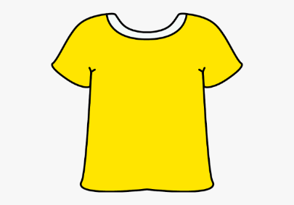  Washing clothes | 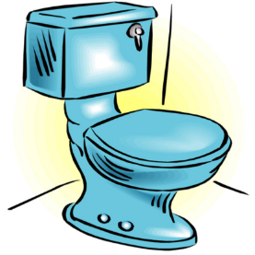  Flushing the toilet
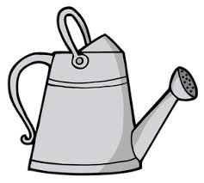  Watering garden | Brushing teeth 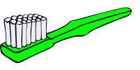
Drinking  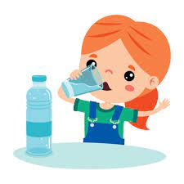 | Cooking  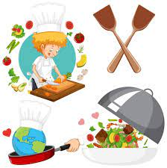
Washing dishes  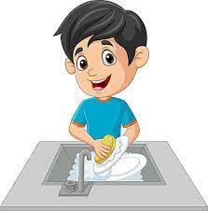 | 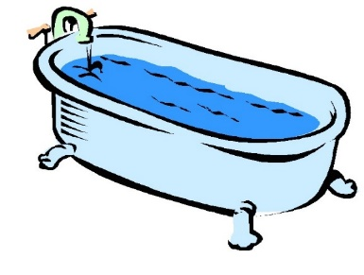  Bathing/ Showering
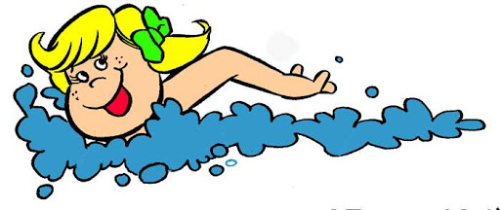  Swimming | 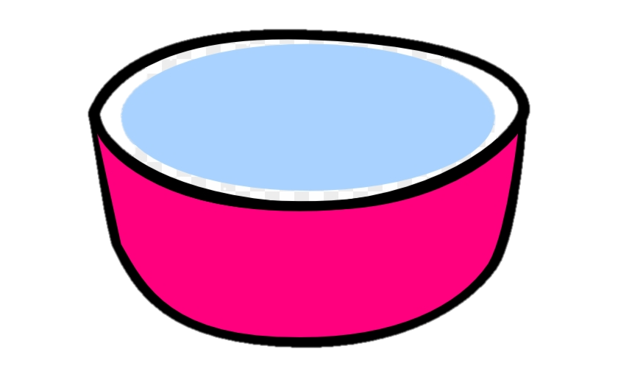  Water for pets

Section 3: Climate Change
Background information
While weather can change dramatically in the course of a day, the climate usually takes thousands of years to change. The climate is changing more quickly than before, therefore, it is becoming a major concern. Climate change is causing more intense and frequent floods, droughts and cyclones across the world. The people who have done the least to contribute to climate change are the ones impacted the worst by its effects. Additionally, they don’t have the money and resources to cope with the conditions they are facing.
Exercise:
Aim: To understand the impact climate change is having on people in the Global South.
Material needed: Case Study on the life of Patricia
Step 1: Read the passage.
Step 2: Discuss how Patricia’s life is similar to yours. How is it different? (Think about family members, pets, daily routine, difference in climate, etc).
Step 3: Discuss the impact of climate change on Patricia’s family?
Step 4: Have you ever experienced the effects of climate change?

Muli bwanji (Hi, how are you?)
My name is Patricia and I am 12 years old. I live with my mother Malita, twin brother Patrick and older siblings Margaret and Kondwani. We reside in a small homestead in the Machinga district of Malawi.
Life can be very difficult in this part of the world as in recent years climate change has meant that weather extremes are much more frequent. On our small farm we try to grow maize as our staple crop. However, in previous years severe drought have meant that our local well has ran dry. This meant that we lacked enough water to irrigate our plants with many of them withering up and dying. It also limited our supply of drinking water.
Every morning during the months of August to November me and my family members have to make the hour-long walk, in sweltering heat to collect water from the nearby stream. We fill large buckets of water to carry on our heads before making the return journey. Sometimes we repeat this task up to five times daily. This makes me feel tired, sore and worried as I am often late for school or am too exhausted to attend.
As well as too little water during the dry season we also experience too much water during the rainy season. Extreme cyclones accompanied by flash floods wash away not only our homes which are made of mud and red brick, but can also destroy our food crops. My brother Kondwani, was seriously injured when part of our house was destroyed when Cyclone Freddy hit in March 2023.
I often spend hours with my goats looking for grass and water but sometimes I find only sand and dust. My father tells me that Turkana has always been dry land but when he was my age life was better. There was enough rainfall and a lot more trees growing which bore fruit for both people and animals. The trees have long since died out. I learn a lot from my father. He is a leader in the community. He calls everyone together to meet and talk about their problems so that they can try to work them out together. The main problem they talk about is the weather and lack of rain. But even he cannot tell me why the weather has changed. He only knows that there will be more difficult times ahead if the drought continues.
Trocaire helps!
Trocaire is helping Nangiro and other communities like hers who face a lot of drought seasons to capture and store water, use more drought resistance crops and look for alternative job options so they don't rely solely on agriculture.

