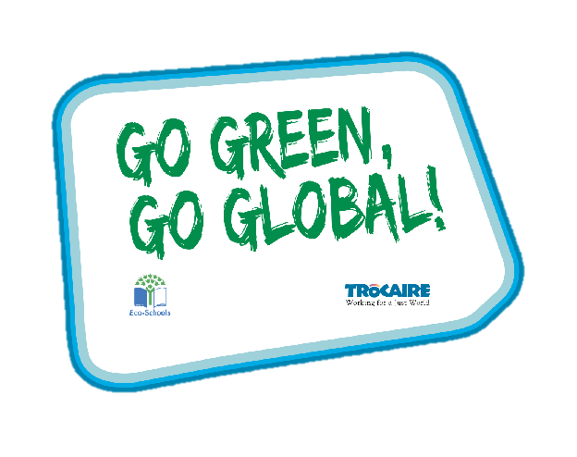
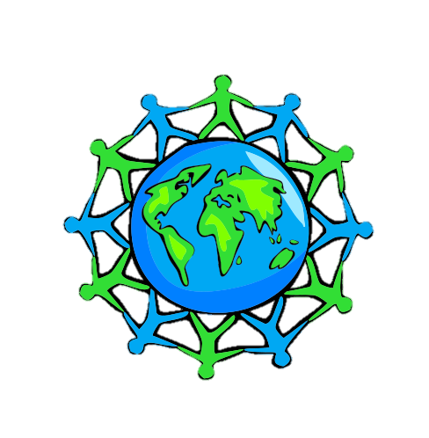
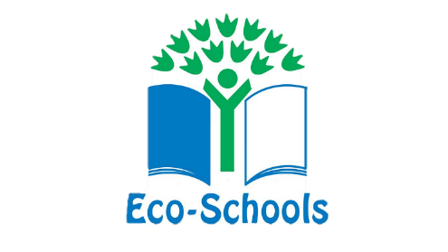
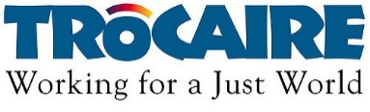



Global Perspective
Water
Climate Change


Key Stage 5

‘Whole Class Activity’Resource Booklet
The purpose of this resource
The Eco-Schools programme in Northern Ireland is operated by Keep Northern Ireland Beautiful and addresses the following eleven topics within schools:
Biodiversity Energy Global Perspective Healthy Living
Litter Marine Transport Waste
Water Climate Change School Grounds (outdoor learning)
In order to qualify for the much acclaimed 'Green Flag' award level, schools must have shown substantial progress towards completing 'one large scale project topic and indicated involvement with two others'.
Through the expertise of the Irish development agency Trócaire, this resource provides a range of activities to incorporate a global perspective into the classroom. It will focus on three of the eleven Eco-School topics and will explain how to introduce and explore these global issues with your pupils.
Each section contains an information sheet on the global issue and one whole class activity.

Content
Section 1 – Global Perspective 3-11
Section 2 – Water 12-13
Section 3 – Climate Change 14

Section 1: Global Perspective
Background information
Global Perspective
The global dimension explores our connections with the rest of the world. With a global dimension to their education, learners can engage with complex global issues and explore the links between their own lives and people, places and issues throughout the world.
The global dimension can inform the whole school ethos, leading to a school that is inclusive, just and democratic and promotes social and environmental responsibility, respect and co-operation.
Citizenship, in its context of fair decision-making, runs throughout the Eco-Schools process. The global perspective topic seeks to ensure that pupils consider the environmental, social and economic impacts of the decisions that they make through this process, on the local and global community, in the future as well as for the present.
Global Citizenship
Being a global citizen is not clearly defined. As there is no global government there are no clear rules and regulations and globally, we do not have democratically elected representatives to speak for us.
Global citizenship is more a moral understanding of our responsibilities and our rights in a global context. Being a true global citizen means that we recognise that all people have equal rights and a unique diversity of opinion.
In addition, it means we should value planet Earth as a very precious resource and one which we all have a need and indeed a responsibility to look after.

The Global Environment
The term environment means surroundings or the conditions in which a person lives. However, it can be narrowly defined. For example, our immediate surroundings as in the classroom environment or very broadly, in relation to the global environment.
One thing that is certain is that humankind has had a huge impact on the environment. Today, many of us have acquired so many things that we have a very comfortable life. But at what cost?
The more that people take from the environment, the more they change the pattern of nature. If we take too much, we risk upsetting this balance.
The balance of nature changes slowly over time but in recent years we have wanted more and more for ourselves, and we are upsetting the balance at a faster rate, without even realising it.
We are part of the natural environment and must look after it. If we upset the pattern too much, we may even destroy ourselves and the lives of future generations.
Trócaire’s focus is on ensuring that our global resources are shared equitably and those in power act for the common good of all.
Global Population
Our precious finite world is currently home to over 7.8 billion people. Numbers this big are difficult to understand but what if we imagined the whole population of the world as a village of just 100 people? In this imaginary village, each person would represent about 78 million people from the real world. One hundred people would fit nicely into a small village. By learning about the villagers – who they are and how they live – perhaps we can find out more about our neighbours in the real world and the problems our planet may face in the future.
Imagining the world as a village also makes it easier for us to start thinking about all the human and environmental problems in the world and what we can do about them. It makes it easier for children to grasp the concept that the world is a large place, and many people in the world live lives much different from our own.

Global Food
There is plenty of food in the world to feed everybody.
The problem is how this food is distributed and shared.
In fact, more than one and a half times the amount of food needed to feed everybody in the world is produced each year.
Yet over 821 million, 1 in 9 people, are hungry.
If there’s really enough food in the world, why do some people still go hungry?
Hunger is caused by many factors and must be solved with many approaches. Factors include lack of investment in small farmers, particular women, unfair international trade policies and climate change.
Exercise 1: How would you spend your money?

Aim: To become aware of their social, environmental and economic impacts

Step 1: Pick 6 things from the list provided, that you feel you need in your life.

Step 2: Using £100, divide how much of that £100 you would spend on each of your 6 wants.

Step 3: Have various pupils share their 6 items and how they spent their money.

Step 4: Explain to them the more money they spent on these items the more they valued them in their lives. Also explain how important some of the items they didn’t choose actually are – they are needs rather than wants e.g. food, rent, heat, electricity – Open this up for discussion if need be.

Exercise 2: If the world were 100 people

Aim: To give a global perspective on how wealthy and privileged people behave compared to their poorer neighbours

Step 1: Teacher to read through each of the categories.

Step 2: Group discussion around the stats provided, to be led by the teacher.

Step 3: Possible questions to get started:
- Are there any figures which really shock you?
- Can you believe that over half the world’s population do not have internet access?
- 1/10 of the world still do not have access to safe water.
- Did you think more people would speak English as a first language?
- Nearly ¼ do not have access to a home or shelter.
- How does this make you feel about your life?
- Do these stats put some of our silly materialistic concerns into perspective?
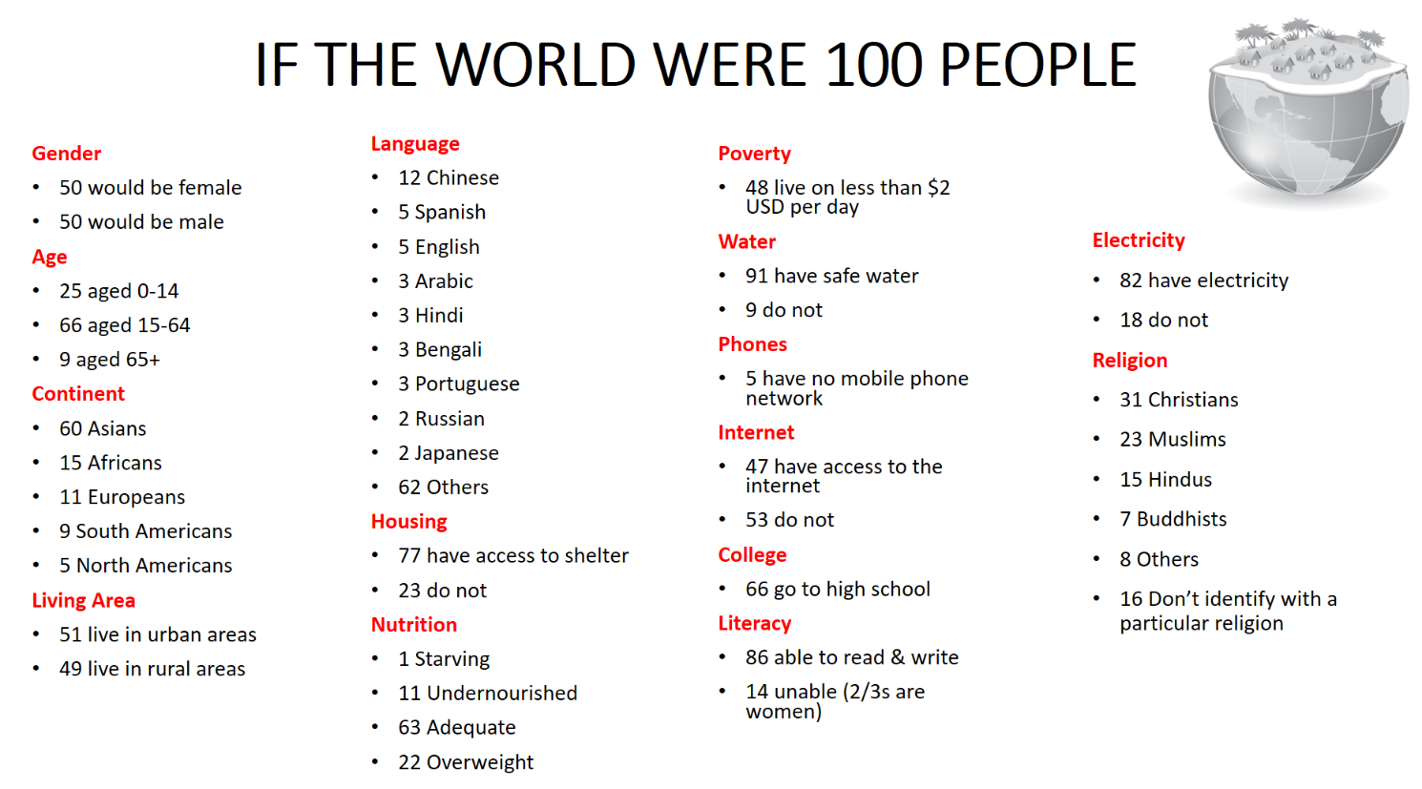

Exercise 3:

Aim: To become aware of their global impact through acknowledging their social and environmental responsibility.

Material needed: Internet access to read article, A4/3 pages, marker for writing, copy of the article for each group.

Step 1: Read the article to the class.

Step 2: Split the class into groups of 4 or 5 students.

Step 3: Explain to the pupils they have a copy of the article in front of them and they must discuss the following:

- How effective are our current recycling systems?
- Should young people be educated in school about the impact of a throwaway society to avoid a scenario whereby the ‘the less they know the less they care’?
- Is it fair that our waste is being dumped in another country?
- Does dumping our waste in another country help or make the environmental situation worse?
- Would this make you reconsider upgrading each time there is a new model of phone or iPad?
- Would you consider avoiding the use of Single-Use Plastics?
- If you could take an individual action, what would it be?
- If your class/year group/school could take a group action, what would it be?

Go through each point and have someone from each group feedback.

The price of a throwaway society: What happens to our rubbish?

What happens to all the stuff we casually toss into a bin? Charlotte Willis investigates the rubbish reality...
Are you finished with that bar of chocolate? Throw the wrapper in the trash! Broken, knick-knacks in your cupboard? Straight into the bin! Cables, coffee cups and cassettes. Anything and everything we don’t need any more eventually finds its way into one form of waste disposal or another. But what happens to trash when it’s swept, thrown and wheeled away from our households, never to be seen again?

Out of sight, out of mind

I suppose we are all accustomed to a very 21st century way of living. We buy items every day, most of which are wrapped in packaging that needs to be disposed of. Thousands of us scrap sandwich and coffee containers daily. We throw out older items that no longer work and clothes that have developed holes. We upgrade our phones, televisions and electronics on a regular basis to keep ahead of tech trends, disposing of our old ones willingly. And we chuck our waste to the curb, like a lazy partner, without any second thought. I suppose we only have ourselves to blame for our throw-away-without-thought lifestyles. Let’s face it, it’s a lot faster to order a new one on Amazon Prime than try to fix, mend, stitch and repair our damaged goods, right?

Our societal disconnect with the goods we consume and those we discard is at the core of some of the most damaging effects that humankind has upon the planet we inhabit. I see waste management (rather, lack of proper management) in the same light as animal agriculture. The less you know, the less you care. The more you know, the more insight you have and the more you become concerned about the current state of affairs.

Throw-away facts

In the UK, our government endorses the need for us all to reduce, reuse and recycle our rubbish as much as possible. Different coloured bins are invading our universities and workplaces, with locally endorsed composting schemes, even a suggested government-endorsed payment-per-bottle recycling programme is under discussion, all in the hope of reducing the amount of waste we produce and send to landfill. But just how effective are these incentives? Here are a few of the current facts regarding our waste-management system in the UK…

Almost half a million tonnes of ‘recycling’ was burned or sent to landfill last year due to contamination or improper sorting, a quantity that is rising every year. Recycling in the UK has plateaued at 44.2%, despite government aims to increase this proportion to 50% by 2020. 8.3 billion metric tons of plastics have been produced since the 1950s – enough plastic to cover every inch of the UK ankle-deep more than 10 times. Of this, a staggering 79% has ended up in landfill or the environment. Only 9% of globally produced plastic has been recycled since production boomed in the ‘50s.’

Saturation point

I don’t suppose many of you have visited a landfill site? I agree, there are much better things to do with your Saturday morning, such as composting your kitchen waste, growing your herb-garden, and fermenting your own yoghurt (I jest, or do I?). Let me paint the picture…
You step out onto what can only be described as a mass of human, man-made detritus, amalgamated in soil and studded with plastic bags, cans and old nappies. Beneath your feet you crunch on bottle tops, coffee cups and packaging. Rising up from the ground upon which you walk, there is a heat, and a noxious, nauseating gas that strikes your nostrils and takes you aback.

Looking up at the brown mosaic-like environment that stretches out before your eyes, miles and miles are littered with old toys, food packaging, paper and broken glass. There’s no end to the sordid, tangled mess of waste as you look around you. Diggers and bulldozers compact the mangled soil as much as they can, and reality starts to sink in. This is the future.

Lessening landfill

Landfill sites have been the world’s dumping grounds for far too long. It has become increasingly apparent that we can’t just bury our heads (and our trash) in the sand. Estimates place landfill as being the disposal method of choice in the early 21st century, with around 90% of our waste going to landfill in 2009.

Since then, massive government-led waste taxes and clampdowns have reduced landfill use to just around 50% of our total waste. This is a vast improvement and a glimmer of hope for environmentalists, but the use of landfill remains. There are fears that incineration will become the next most popular option for waste destruction, but this also ensues a toxic concoction of lethal gas production. It seems we are stuck between a rock and a hard place.

E-Waste

A recent BBC documentary startled and disturbed me. Reggie Yates: A Week in a Toxic Waste Dump was a stark exposé into the underground, and often unmentioned world, of e-waste management and electronic goods recycling methods used by many countries, including the UK. I sat there, horrified, as boys and men as young as 16 exposed themselves to poisonous gases, burning old electrical goods to extract the metals lying under plastic shells and encased in synthetic materials, to sell for a matter of pence to recycling merchants. I vowed to hold onto my e-goods for the long run.

The documentary focuses on Ghana, which seems to be the UK’s hot spot for dumped electrical goods. We ship thousands of tonnes to foreign, often poorer, countries like Ghana and China every year. On a global scale, 41 million tonnes of e-waste are discarded yearly. Of this, the UK is responsible for 1.5 million tonnes. That’s basically 15 shipping containers worth of e-goods landing in Ghana every single day.

What makes e-waste so damaging is the vast amounts of by-products that pollute the soil and rivers, and the people that sort through it. Mercury leaks from old appliances; lead that is burnt pollutes the soils and coats the lungs in a toxic ash; cadmium from batteries finds its way into the water supply, causing organ failure and childhood developmental issues. Electronic waste causes arsenic, zinc and flame-retardants to be found in toxic concentrations in the air, water, and even on the fruits and vegetables at the wholesale market.
What’s worse is that many of the products come from supermarkets and UK e-waste recycling schemes which encourage a trade-in of your old laptop/phone etc for a monetary payback. Makes you think twice about upgrading your iPhone.

‘Plastic’ is a swear word

No. Take me seriously here, please!

Put simply, plastic is the sworn enemy of the environment, and one of the single most polluting and harmful contaminants in the world. By 2050 it is estimated that there will be a tonne of plastic for every tonne of fish in our oceans, rivers and seas. This doesn’t consider the millions of tonnes of plastic that are non-recyclable every year. A massive 79% of all plastic ever produced has ended up in landfill, with only 9% being recycled. We produce single-use plastics such as bags and bottles that last about 10 minutes in our daily lives but stay around in our environment for hundreds of years. In fact, every piece of plastic that has ever been made, still currently exists on our planet, in one form or another, today.

Despite what many may think, plastic can’t be fully recycled. Instead, it is involved in a process known as “downcycling”, which uses other forms of plastic to create new, lower-quality forms of plastic used for bags and bin liners etc. Throw into the mix the toxicity of certain types of plastic, the amount of fossil fuels and oil we need to extract (17 million barrels each year just for plastic water bottles – I kid you not!), the energy required to refine this material and the non-recyclable plastics that are found in nappies, sanitary products and that line your coffee cups, and plastic doesn’t seem like such a wonderful idea.
BPA and other chemical components of plastic have been experimentally shown to be absorbed into the body, altering our hormonal signalling mechanisms and leading to complicated health conditions such as infertility. It gives a new meaning to the phrase “bag for life”.

Take action

It’s easy to be despondent when it comes to these issues facing society. As many will relate, being vegan comes hand in hand with the challenge of facing adversity, while attempting to make an impact upon a world that doesn’t seem to have a moral compass. The generational loss of contact with our environment has resulted in catastrophic wastefulness in an all-out conflict of interest between hedonism and our need for future resources.
So what do I propose? Put simply, I encourage us all to reconnect. To slow down. If you think, and really ponder for a second, just who and how and where your waste goes to die, you might find yourself questioning, regretting the consequences of the purchases and throw-away habits that form such a consumable life.

Look at your waste bin. How much of that waste did you really need to create? Could you find sustainable alternatives such as a metal coffee cup, repairing that old pair of jeans, or taking your own bags for vegetables at the grocery store? Simple switches, but if everyone employed these strategies, we would all be in one hell of a smaller mess than our current rubbish situation.
The ultimate fact remains, most of our waste is not dealt with in a long-term sustainable or environmentally sound manner. We are choking our planet, covering it in a pile of non-biodegradable garbage. Seeping toxic matter into our soils, burying it underground, burning it, dumping it into our vast oceans and leaving the most vulnerable communities in the globe to sift through it. Enough is enough.

Section 2: Water
Background information
The River Nile is the world’s longest river, it runs alongside Egypt, Sudan and Ethiopia. Ethiopia wants to construct the Grand Renaissance Dam, so that it can generate enough electricity to gain significant income from it. The Minister for Water, Irrigation and Electricity supports this decision, stating: “It’s not about control of the flow, but providing opportunity for us to develop ourselves through energy development. It has a lot of benefit for the downstream countries”. However, Egypt opposes this initiative as it may result in a reduction in their water flow. 85% of the river emerges from the Ethiopian highlands so they have the capability to control the flow of water.
Exercise: Grand Renaissance Dam – Water as a Shared Resource
Aim: To understand how water flow can impact its ability to be a shared resource.
Material needed: Access to computer
Step 1: Watch the video provide on this BBC page: www.bbc.co.uk/news/world-africa-43170408 to educate the class on the current issues about enhancing the Grand Renaissance Dam
Step 2: Discuss as a class, the following questions:
Should you control water?
Can you share water fairly?
Who owns the water?

Step 3: Now split your class into groups of 7. Each person takes the role of one of the following: dam construction officer, local from Egypt, local from Ethiopia, local from Sudan, Minister for Water, Irrigation and Electricity (Ethiopia), Minister of water resources and irrigation (Egypt), government representative (listens and make final decision).
Step 4: Where you able to reach a decision? What were the challenges you faced?

Role-play characters and key points
Dam construction officer  - For the building of the dam  - Giving him/her work  - Resident of Ethiopia who will benefit from its construction | Local Egyptian resident  - Against the building of the dam  - Has a religious attachment to the River Nile  - Afraid of water scarcity due to reduced water flow because of the dam  - There is a prediction of a water shortage for 2025
Minister of Water, Irrigation and Electricity (Ethiopia)  - For the building of the dam  - Has the power to generate hydroelectrically power for the entire country  - Economic benefits attached | Local Sudanese resident  - For the building of the dam  - The dam will provide a flow of water all year round  - In the past the difference between high and low water level were 8m, the dam will reduce this to 2m  - Ideal for farming and irrigation projects
Minister of water resources and irrigation  - Against the building of the dam  - Has the responsible to care fo a nation of 100 million people  - A 2% reduction in water flow coming into Egypt will result in 200,000 acres of land being lost | Local Ethiopian resident  - For the building of the dam  - Benefit personally, with the ability to use the hydroelectric power it will produce  - Benefits economically as a country  - A sense of pride

The government representative will listen to all parties present and then make the final decision on whether the construction of the Great Renaissance Dam continues to proceed.

Section 3: Climate Change
Background information
Climate change is a major issue which has an impact on everyone’s life, whether they are aware of it or not. Climate change is caused by human’s exploiting the Earth’s nature resources. In reality, we are consuming too much for the Earth to cope with. A major contribution to climate change is the vast number of cars on the road. The emission from cars severely increases CO₂ levels.
Exercise: Who fights climate change debate?
Aim: To identify who is/should be responsible when it comes to fighting climate change
Step 1: Explain to the class that a healthy planet can provide enough clean air, water, food, energy and shelter for everyone. Yet our world is under treat. Those with the least power, wealth and resources suffer the worst effects of environmental destruction and receive less than their fair share of the planet’s resources. But we can do something about it.
Step 2: Divide the class into groups of 6. Each student takes the role of one of the following: Car manufacturer, School student, Environmental activist, Parent, Government representative, school principal.
Step 3: The title of this debate is “There are too many cars on the road”. How can schools reduce the use of cars going to and from school? What are the barriers preventing change in this area? Should there be fines for idling?
Step 4: If you were able to come up with an environmentally friendly positive solution, investigate it further. Can your school be eco-friendlier by reducing car use?
Step 5: To those we say, ‘what difference could we make?’, respond ‘a lot’. By taking this first small step, you are challenging the way people live and inspiring those to follow in your footsteps. If everyone in the developed world, take responsibly for their actions and adapted change in their lifestyles, climate change would reduce and conditions in developing countries would become less devastating.

