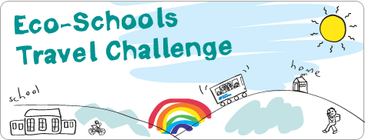

Teachers’ Tips
Brilliant! You have decided to take part in the Translink Eco-Schools Travel Challenge. What are the best ways to encourage pupils, parents and other teachers to take part?
The Translink Eco-Schools Travel Challenge Toolkit includes a letter to parents which you can adapt to suit the needs of your school and the needs of these current times.
Perhaps some of the following ideas will help you and the parents to improve the school run and encourage everyone to get out of the car and stretch their legs!
Really good reasons to do the travel challenge –
- It’s healthy
- It’s good for the environment
- It’s social and fun – have a good chat on the way! Remember to keep it to your bubble.
- It could save petrol money
- Pupils who walk or cycle to school are more alert and do better in class
- It will help solve congestion at the school gates
- It helps Primary pupils transition to travelling to Post-Primary Schools
- It will help your work toward an Eco-Schools award
- You could win a prize

Ideas for your travel challenge –
Create a ‘Walking Bubble Bus’
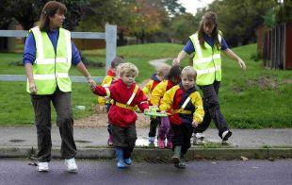
This is a great idea for younger pupils or busier travel routes where parents may not feel confident in letting their children walk on their own. Teachers, parents or governors can take the position of ‘Driver’ at the front of the queue and ‘Conductor’ at the back. The bus might take a specific route through your area to pick up pupils or walk from a designated drop off point. Perhaps for each bubble shifts in days and time are a good idea. All the pupils walk together in their assigned small group, which keeps them safe. High-visibility vests are a good idea if you have them, particularly for the ‘Driver’ and ‘Conductor’. A small reward for those taking part is a good incentive.
Park and Stride
If the area around your school is really congested with school run traffic at drop off and pick up times have a look further away for an area where parents could safely park and the pupils could walk the remainder of the way. Quite often local shops with big parking areas might be willing to help you with the Travel Challenge by letting parents use their car-park – after all it’s good for business. Perhaps a local church or sports centre could help you in the same way. Pupils from the same bubble can walk in small groups from the drop off point or you could set up a ‘Walking Bubble Bus’ for younger pupils.
Have a WOW day
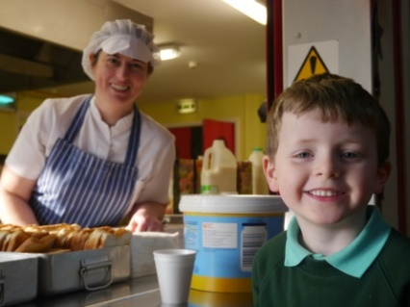
WOW stands for Walk/Wheel Once a Week or Walk/Wheel on Wednesdays. Encourage everyone to take part – parents too! Make it a real event, perhaps with fancy dress and an incentive such as a sticker or small prize for those who take part. Food always works well too! How about a ‘bike for breakfast club’ or a favourite lunch dish on your big day?
Get transport savvy – Something interesting to learn while being at home!
Go online with your pupils in class, or encourage them to investigate at home with parents, to research the bus and train routes in your area. Use the online travel planner and timetables at www.translink.co.uk to work out a transport plan to and from school. Younger pupils can travel in assigned groups or with parents. For Primary School pupils it’s great preparation for future travel to Post-Primary education. It’s also a great way to use maths skills and build independence and confidence.
Set a target – be serious about your challenge!
A little competition always helps pupils (and teachers!) to strive harder. Why not set up a prize for the best pupil effort in your class or at home each week of the challenge or compete between classes in the school. Setting a target like a certain amount of eco-kilometres reached by your class is great encouragement and a good use of maths skills too. Your excel Travel Challenge worksheet should help you work this out - for example, Magherafelt Primary School set themselves a ‘Lap the Lough’ challenge and managed to walk the distance around Lough Neagh three times during their challenge! How many kilometres could your class save? Why not counting also the kilometres while enjoying the great outdoors for a walk with their family?
Finally of course there are some fabulous prizes provided by Translink for taking part in the Travel Challenge in many different categories. £150 cash to £300 cash in the 2 main categories as we can't offer the coach hire element at the moment. Individual winner category could still get family travel ticket and book token as usual.
Information on all the prizes is provided in your Travel Challenge Toolkit or on www.translink.co.uk/ecoschools
Teaching Resources -
Re-enforce your travel message by using the specially developed teaching resources for KS1, KS2 and KS3 available at www.translink.co.uk/ecoschools. The resources contain lesson ideas, activities and fun worksheets investigating travel issues.

