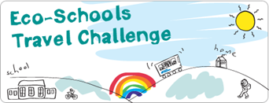
Now enter your results into the Eco-Schools online Data Zone to submit your Translink Travel Challenge results to support your Green Flag application.
www.eco-schoolsni.org

