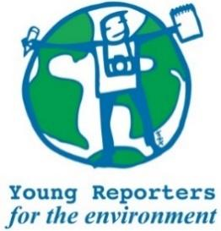
YRE International Competition
Competition entry form 2024/2025
Category: Podcast

Questions marked with * must be answered.
Age group* | ☐ 11-14 years  ☐ 15-18 years  ☐ 19-25 years
Name of student(s)*
Name of school*
City and Postcode of school*
Age(s) as of National Competition deadline*
Theme of entry* | ☐ Pollution  ☐ Climate Change  ☐ Loss of Biodiversity  ☐ Other
If ”Other” was chosen in the above question, please specify the theme here.
Type of podcast* | ☐ Audio only  ☐ Visual and Audio
Title of the submission (within 140 characters)*
The submission must be uploaded to YRE's Exposure page for the International Jury to assess. Please insert the link here*
Is the link to a segment of the podcast no longer than 5 minutes?* | ☐ Yes / ☐ No
Is the title within 140 characters?* | ☐ Yes / ☐ No
Is the podcast of good quality (including sound quality)?* | ☐ Yes / ☐ No
Are the facts, statistics, scientific information, and quoted supported by real and credible sources?* | ☐ Yes / ☐ No
Are the sources (including external audio such as music, sounds effects, soundbites) used in the podcast cited on a seperate Works Cited list (MLA style)?* | ☐ Yes / ☐ No
Is the podcast a fair and truthful representation of reality and the sound or recording has not been edited?* | ☐ Yes / ☐ No
Does the podcast include relevant and feasible solutions to the environmental issue presented?* | ☐ Yes / ☐ No
Is the podcast made of at least 70% of the student's own original voice recording and audio?* | ☐ Yes / ☐ No
Where has the submission been disseminated?* | ☐ Personal Sphere (through social media such as Instagram, TikTok, YouTube, etc.)  ☐ School Community (through the school website, social media, etc.)  ☐ Eco-Schools NI (through the organisation's website or social media channels)  ☐ National Media (through newspaper, TV, radio, etc.)  ☐ Other
Please attach or list evidence of dissemination (links and/or photos) that show where your submission was shared with others.*
Student(s)' explanation of how the submission addresses the link between the topic and the chosen Goal(s)*
You can read about the SDGs here: https://sdgs.un.org/goals

